**Launching template and configuring the auto scaling**

**Launch** Templates. A **launch template** is similar to a **launch** configuration, in that it specifies instance configuration information. Included are the ID of the Amazon Machine Image (AMI), the instance type, a key pair, security groups, and the other parameters that you use to **launch** EC2 instance

**Launch Templates** is a new capability that enables a new way to templatize your **launch** requests. **Launch Templates** streamline and simplify the **launch** process for Auto Scaling, Spot Fleet, Spot, and On-Demand instances

According to my scenario

Here i am taking a customized image in this template

Now giving new name for template and giving version and also enable the option which template using for further in auto scaling 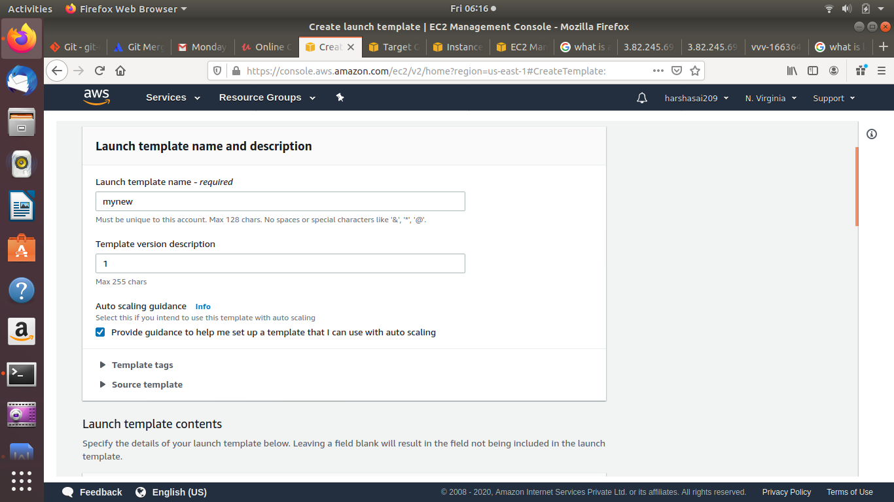

Assigning the customized ami

Type of instance

Key pair name

**EC2**-**Classic** is the original release of **Amazon EC2**. With this platform, instances run in a single, flat network that is shared with other customers. With **EC2**-**VPC**, instances run in a virtual private cloud (**VPC**) that is logically isolated to only one **AWS** account.

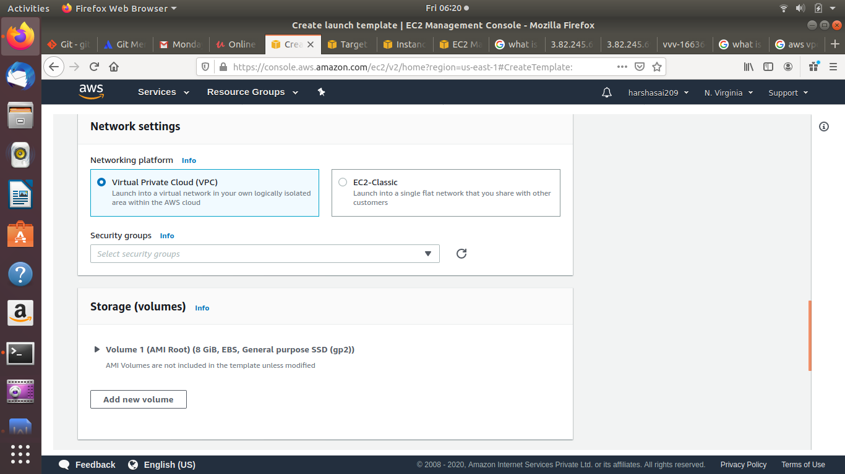

Now changing the network interface and enabling the public ip and giving vpc security groups

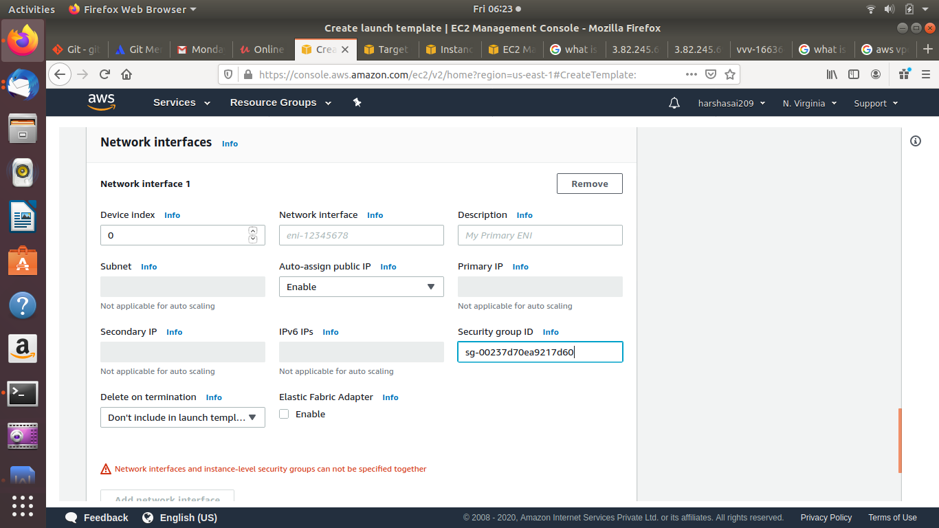

Here we have to give only one time for security groups in it

Now template is created successfully

Now configuring the auto scaling with template

Go to auto scaling group

Select launch template

And select the bottom created template here

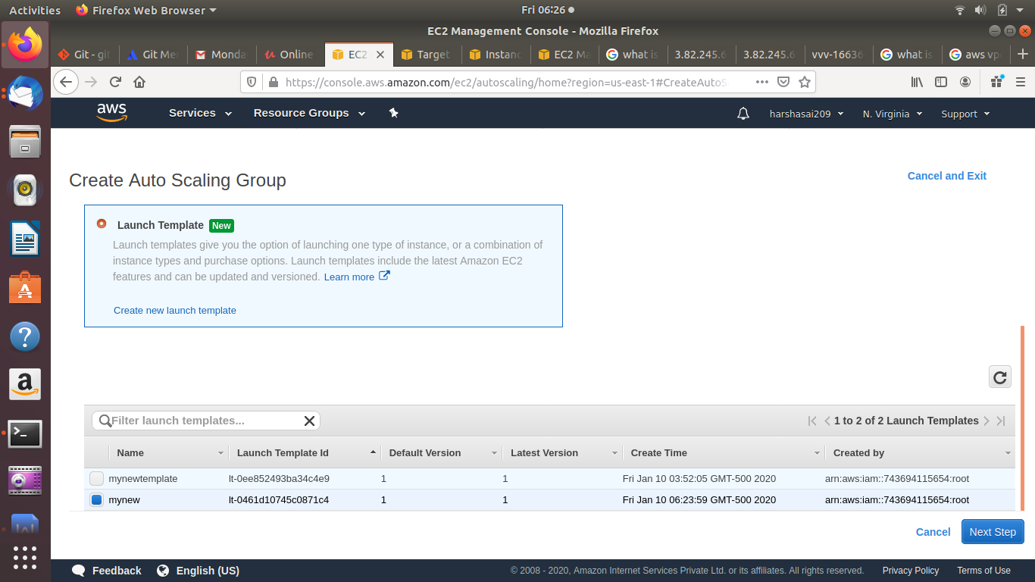

Now giving name for group and selecting customized vpc and also sub nets with availability zones

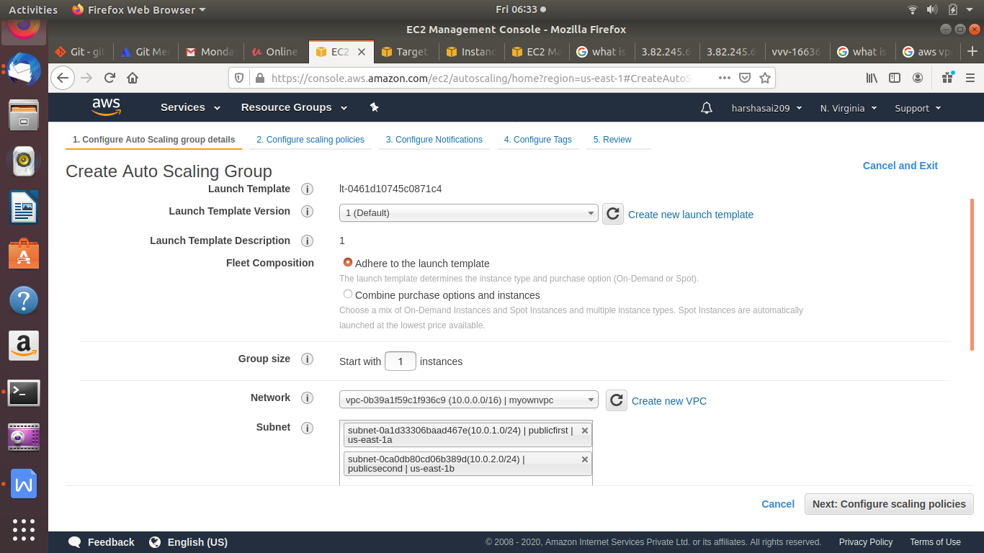

Suppose any load balancer group is created we can add here

With adding of load balancer group while this auto scaling template can attach in use of load balancer configuration

If we does not have any existing load balancer target groups column is not reflects here

By default

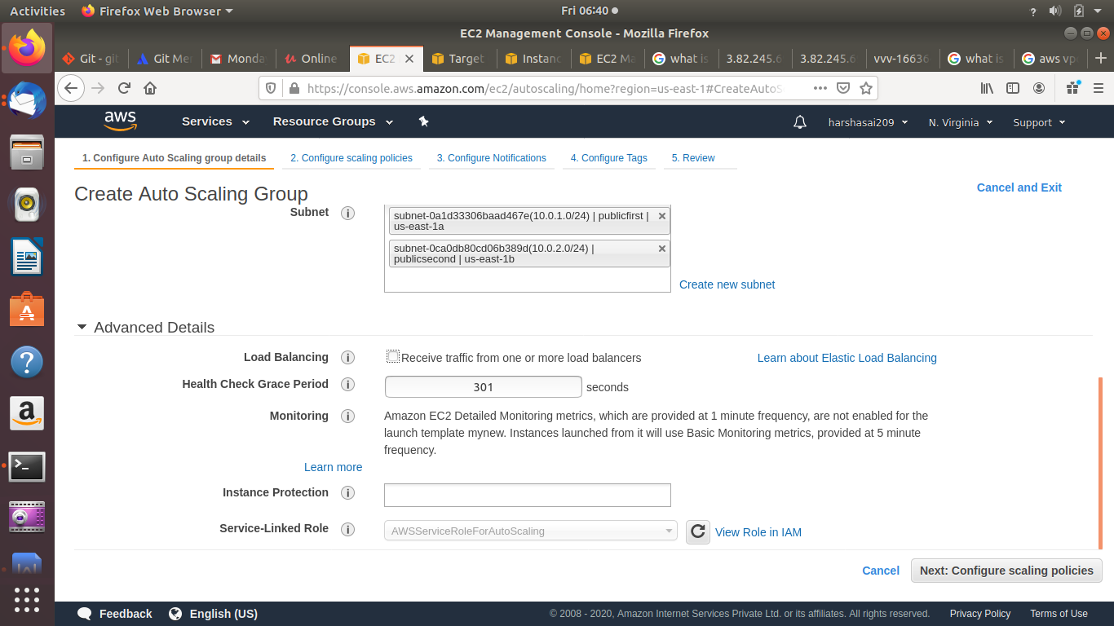

Changed one

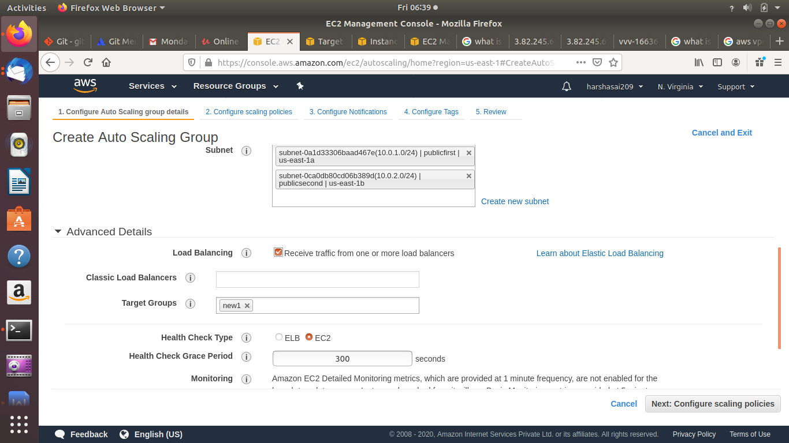

Now we have adjust the capacity of auto scaling group

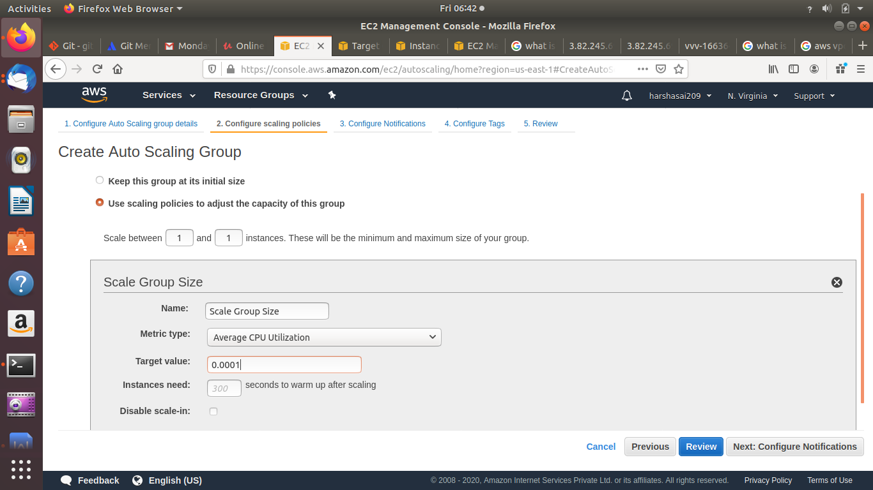

We have notification setup also available

Tags

Review and launching the auto scaling

**Successfully created Auto Scaling group**

**Now adding load balancer to auto scaling**

**We already given group name in auto scaling configuring**

**While creating load balancer we create with existing load balancer target group**

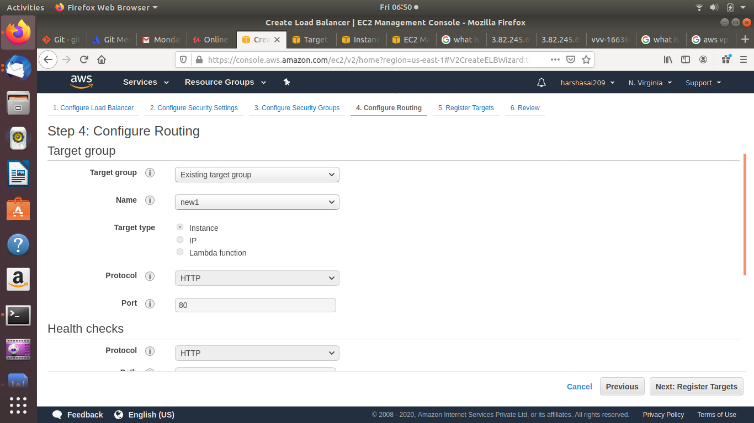

Register targets are already allocated with instances

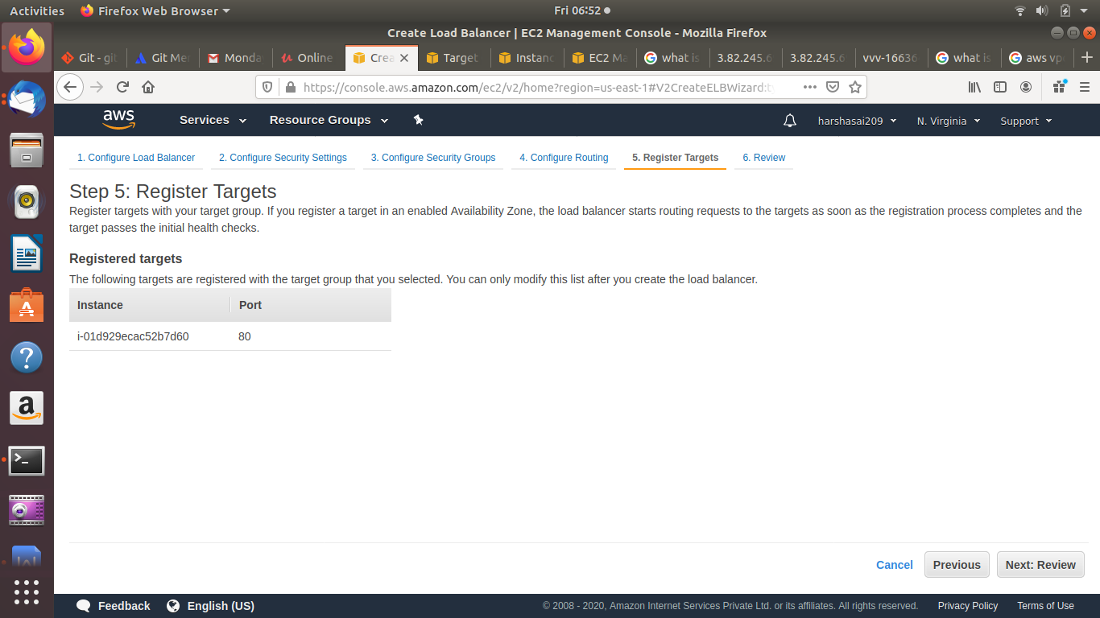

Now created auto scaling successfully